Table of Contents

Program 1 Array operations 2
Program 2 Employee Structure 8
Program 3 Stack Implementation 11
Program 4 Infix to Postfix Conversion 14
Program 5 Evaluation of Postfix Expression 17
Program 6 Recursion applications 21
6a. Binary Search 21
6b. Tower of Hanoi problem 23
Program 7 Call holding in call center 24
Program 8 Circular Queue using Structure 29
Program 9 Linked list for sorted names 34
Program 10 Stack using Linked List 38
Program 11 Doubly Linked List implementation 43
Program 12 Binary Search Tree implementation 48

Program 1 Array operations
Design, Develop and Implement a menu driven Program in C for the
following array operations.
a) Creating an array of N Integer Elements
b) Display of array Elements with Suitable Headings
c) Inserting an Element (ELEM) at a given valid Position (POS)
d) Deleting an Element at a given valid Position(POS)
e) Exit.
Support the program with functions for each of the above operations.

Warning! You are warned against blindly copying the code statements. Read the code and comments to understand the implementation. Then, try to do it yourself. Blindly re-typing the code statements is a waste of time & effort.

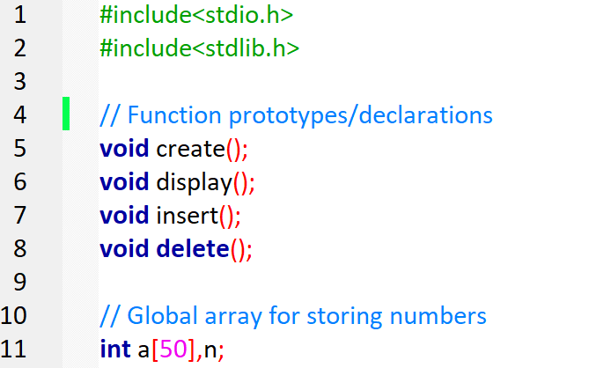
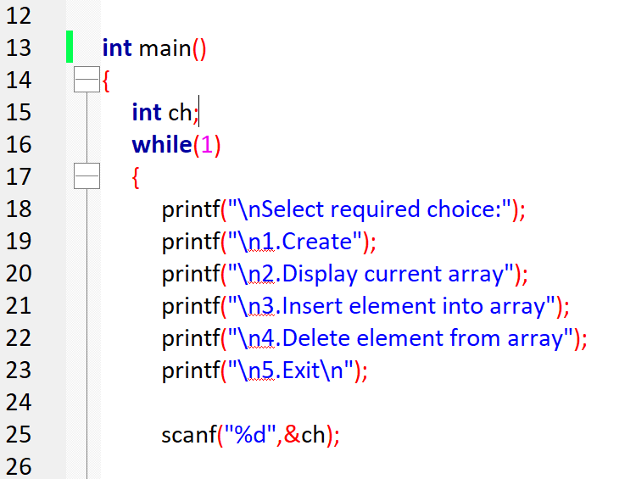
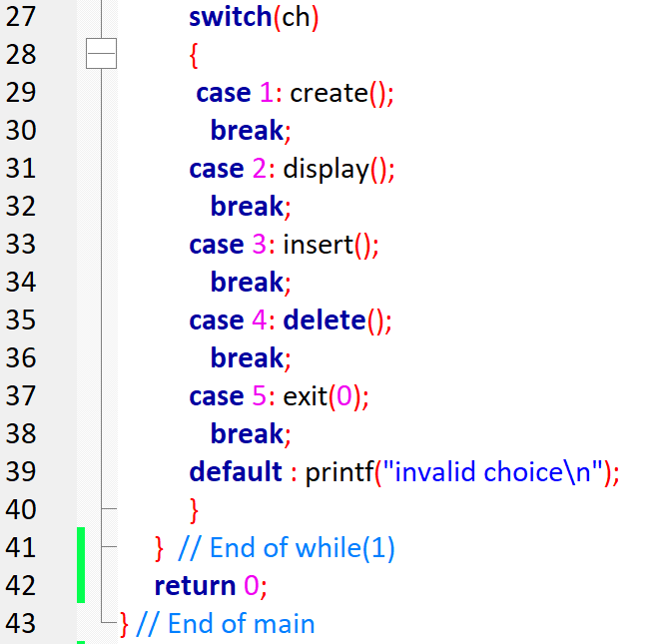
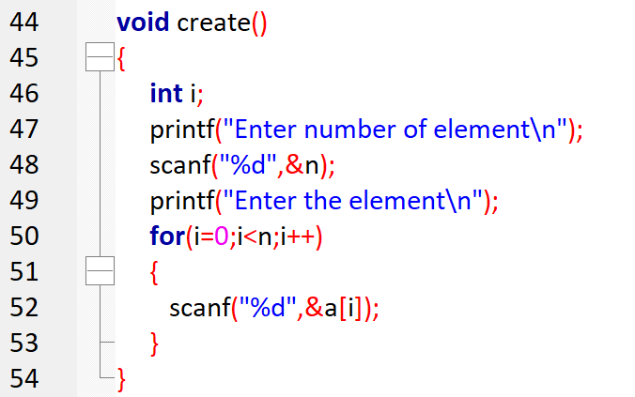
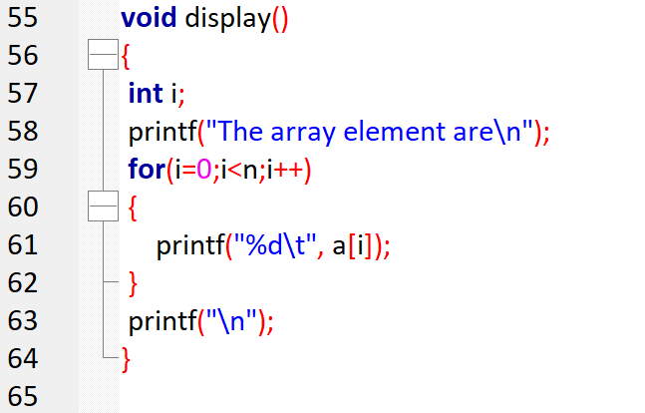
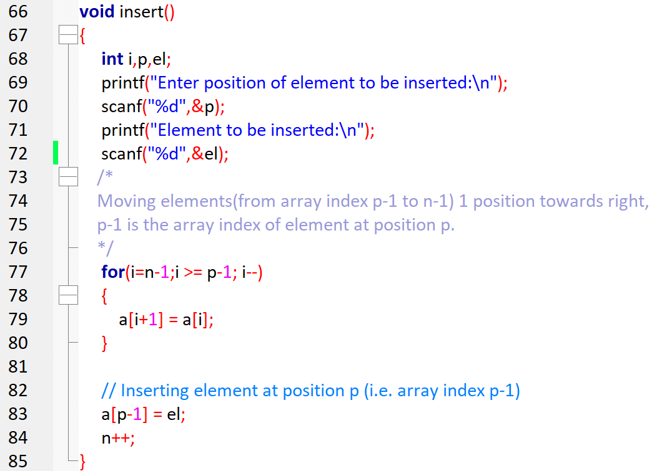
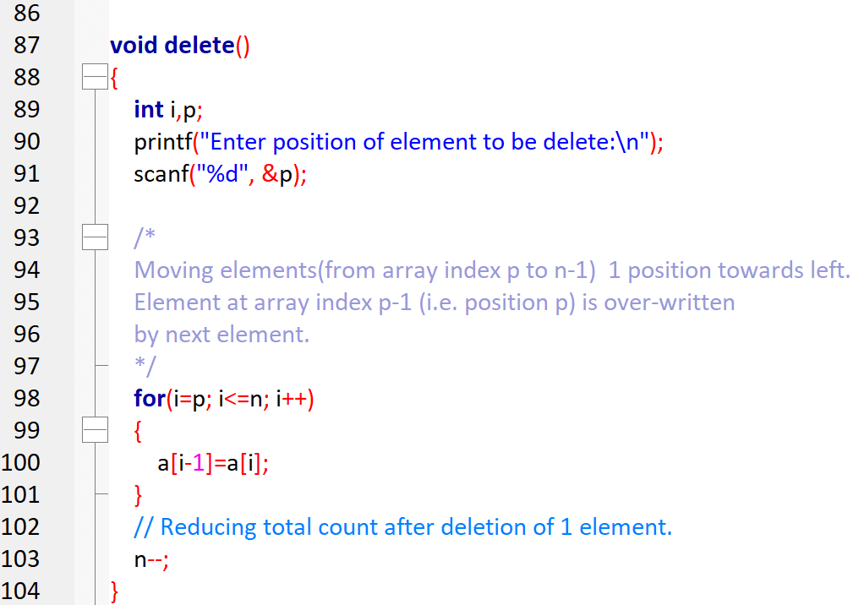

OUTPUT:
Select required choice:
1.Create
2.Display current array
3.Insert element into array
4.Delete element from array
5.Exit
1
Enter number of element
4
Enter the element
10
20
30
40

Select required choice
1.Create
2.Display current array
3.insert element into array
4.Delete element from array
5.Exit
2
the array element are
10 20 30 40

select required choice
1.Create
2.Display current array
3.insert element into array
4.Delete element from array
5.Exit
3
Enter position of element to be inserted
2
element to be inserted
50
select required choice
1.Create
2.Display current array
3.insert element into array
4.Delete element from array
5.Exit
2
the array element are
10 50 20 30 40

select required choice
1.Create
2.Display current array
3.insert element into array
4.Delete element from array
5.Exit
4
Enter position of element to be delete
5

select required choice
1.Create
2.Display current array
3.insert element into array
4.Delete element from array
5.Exit
2
the array element are
10 50 20 30

select required choice
1.Create
2.Display current array
3.insert element into array
4.Delete element from array
5.Exit

Program 2 Employee Structure
Define an EMPLOYEE structure with members Emp_name, Emp-id, Dept-name and Salary. Read and display data of N employees. Employees may belong to different departments. Write a function to find total salary of employees of a specified department. Use the concept of pointer to structure and allocate the memory dynamically to EMPLOYEE instances.

Warning! You are warned against blindly copying the code statements. Read the code and comments to understand the implementation. Then, try to do it yourself. Blindly re-typing the code statements is a waste of time & effort.

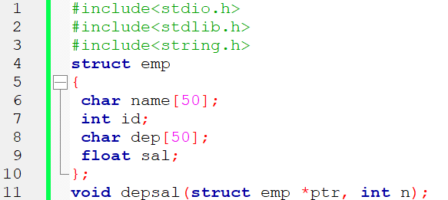
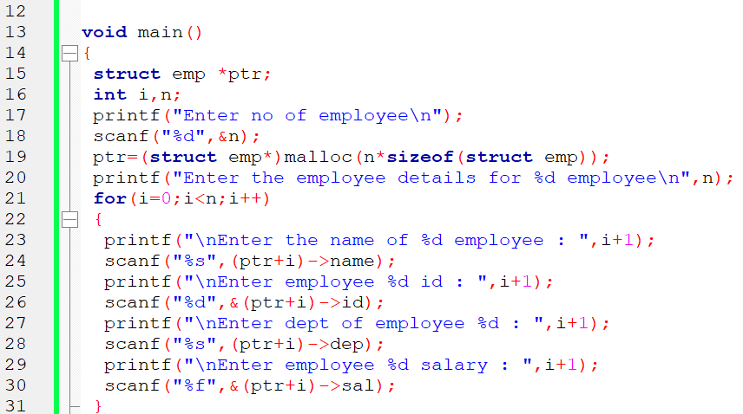
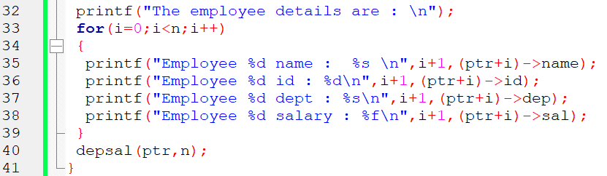
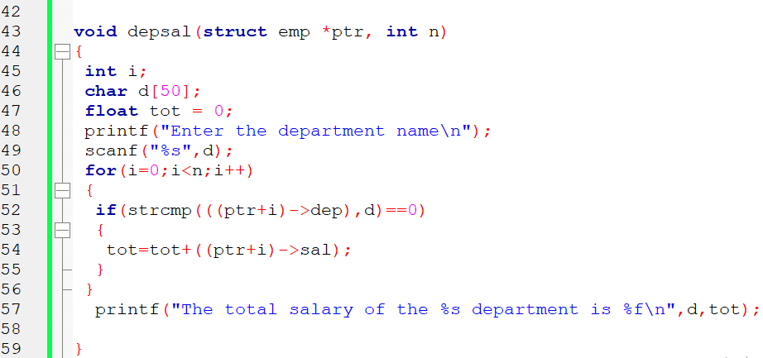
OUTPUT
Enter no of employee
3
Enter the employee details for 3 employee

Enter the name of 1 employee : tabraiz
Enter employee 1 id : 10
Enter dept of employee 1 : cse
Enter employee 1 salary : 70000
Enter the name of 2 employee : kshitij
Enter employee 2 id : 20
Enter dept of employee 2 : cse
Enter employee 2 salary : 80000
Enter the name of 3 employee : jeet
Enter employee 3 id : 30
Enter dept of employee 3 : ise
Enter employee 3 salary : 60000
The employee details are :
Employee 1 name : tabraiz
Employee 1 id : 10
Employee 1 dept : cse
Employee 1 salary : 70000.000000
Employee 2 name : kshitij
Employee 2 id : 20
Employee 2 dept : cse
Employee 2 salary : 80000.000000
Employee 3 name : jeet
Employee 3 id : 30
Employee 3 dept : ise
Employee 3 salary : 60000.000000
Enter the department name
cse
the total salary of the cse department is 150000.000000

Program 3 Stack Implementation
STACK of Integers (Array Implementation of Stack with maximum size MAX)
a) Push an Element on to Stack
b) Pop an Element from Stack
c) Check if stack contents form a palindrome
d) Demonstrate Overflow and Underflow situations on Stack
e) Display the status of Stack
f) Exit
Support the program with appropriate functions for each of the above
operations

Warning! You are warned against blindly copying the code statements. Read the code and comments to understand the implementation. Then, try to do it yourself. Blindly re-typing the code statements is a waste of time & effort.

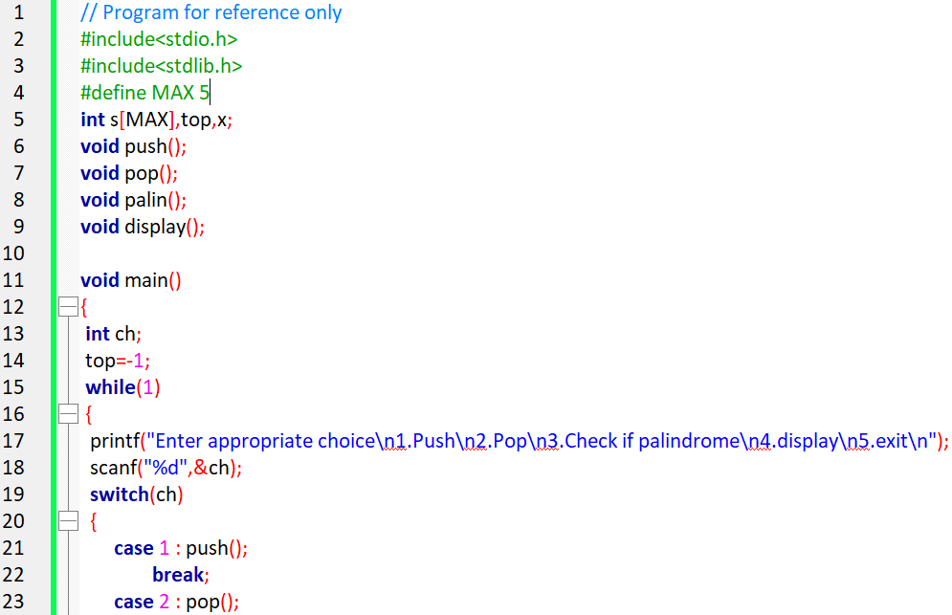
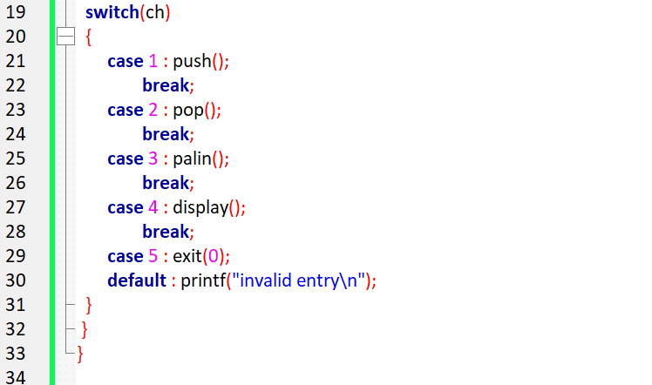
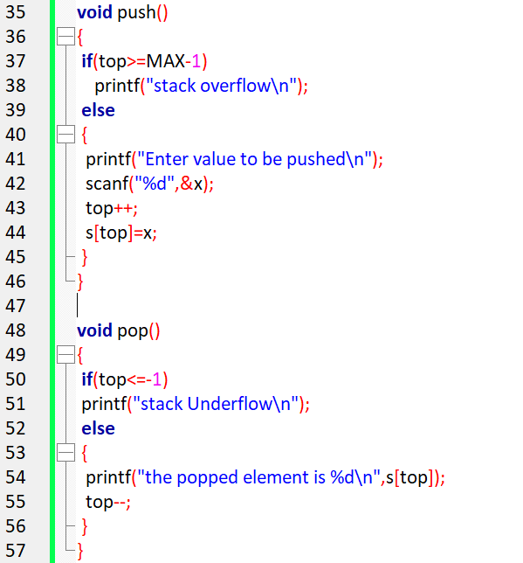
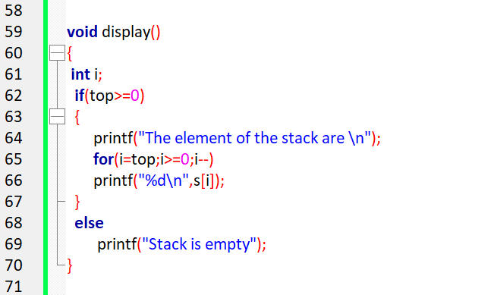
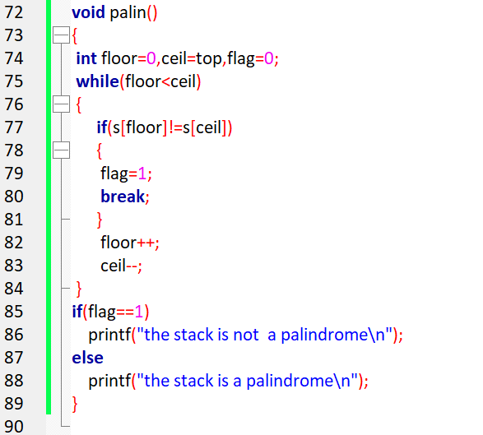

Program 4 Infix to Postfix Conversion
Write a C program to convert and print a given valid parenthesized infix arithmetic expression to postfix expression. The expression consists of single character operands and binary operators + - * /. Apply the concept of stack data structure to solve this problem.

Warning! You are warned against blindly copying the code statements. Read the code and comments to understand the implementation. Then, try to do it yourself. Blindly re-typing the code statements is a waste of time & effort.

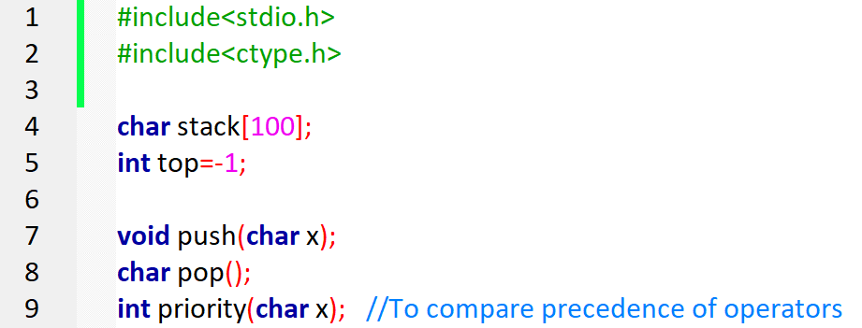
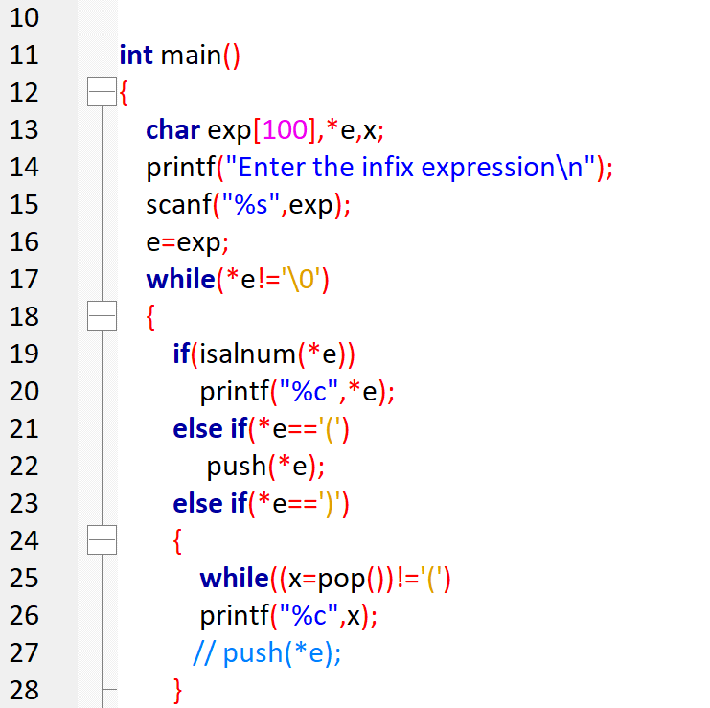
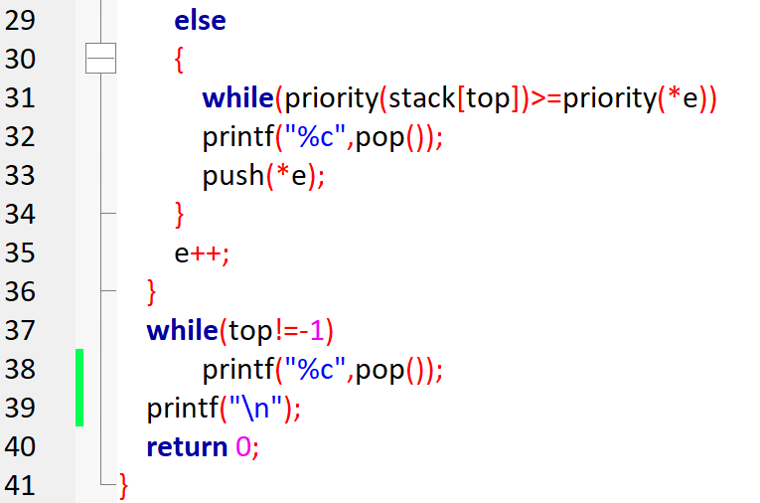
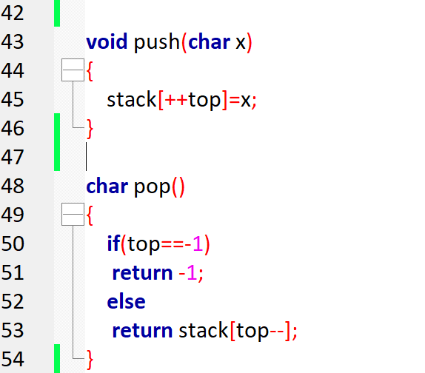
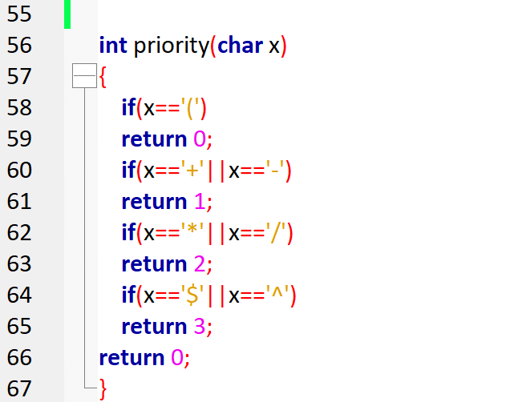

OUTPUT

Enter the infix expression
A+B/C*(D-E)
ABC/DE-*+

Enter the infix expression
A+B*C
ABC*+

Program 5 Evaluation of Postfix Expression
Write a C program to evaluate a valid postfix expression using stack. Assume that the postfix expression is read as a single line consisting of non-negative single digit operands and binary operators. The operators are + - * and /.

Warning! You are warned against blindly copying the code statements. Read the code and comments to understand the implementation. Then, try to do it yourself. Blindly re-typing the code statements is a waste of time & effort.

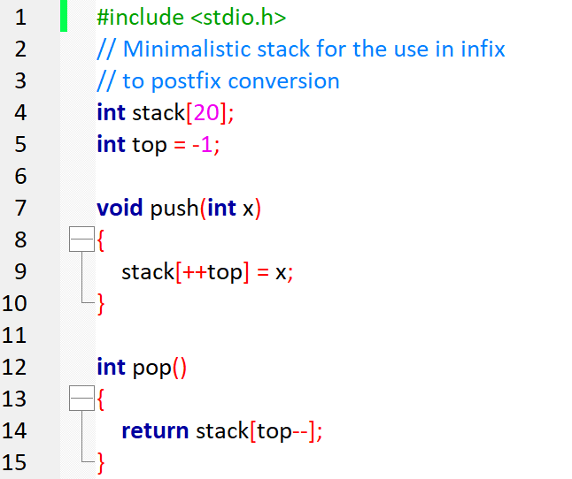
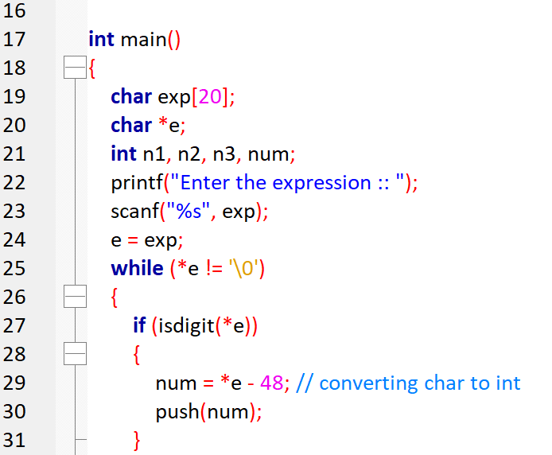
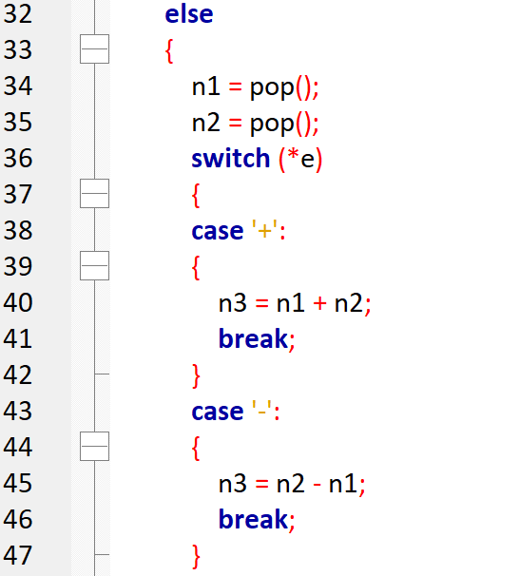
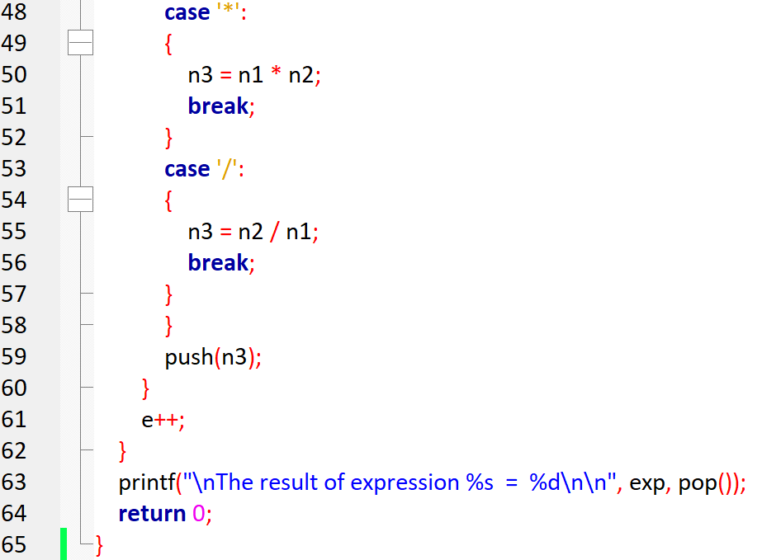
OUTPUT

Enter the postfix expression
53+62/*35*+
Thes result of 53+62/*35*+ = 39

Program 6 Recursion applications
Write recursive functions for the following and demonstrate their use.
a) Binary Search
b) Tower of Hanoi problem

Warning! You are warned against blindly copying the code statements. Read the code and comments to understand the implementation. Then, try to do it yourself. Blindly re-typing the code statements is a waste of time & effort.

6a. Binary Search
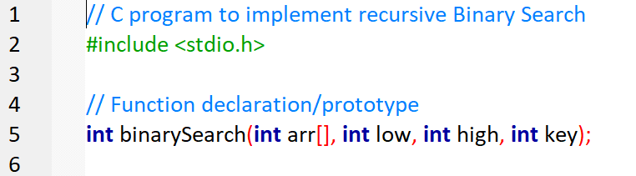
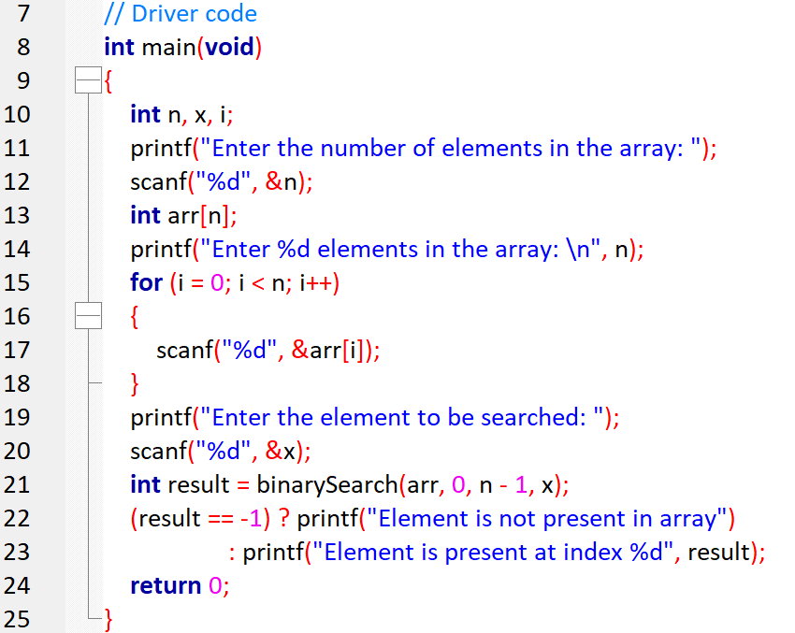
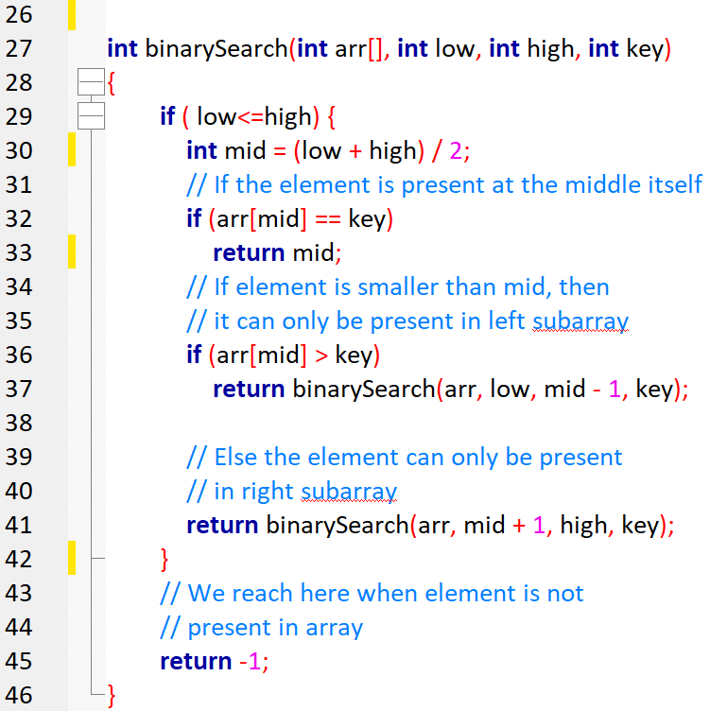

OUTPUT:
Enter the number of elements in the array: 5
Enter 5 elements in the array:
1 4 7 9 12
Enter the element to be searched: 9
Element is present at index 3

Enter the number of elements in the array: 5
Enter 5 elements in the array:
1 4 7 9 12
Enter the element to be searched: 15
Element is not present in array

6b. Tower of Hanoi problem
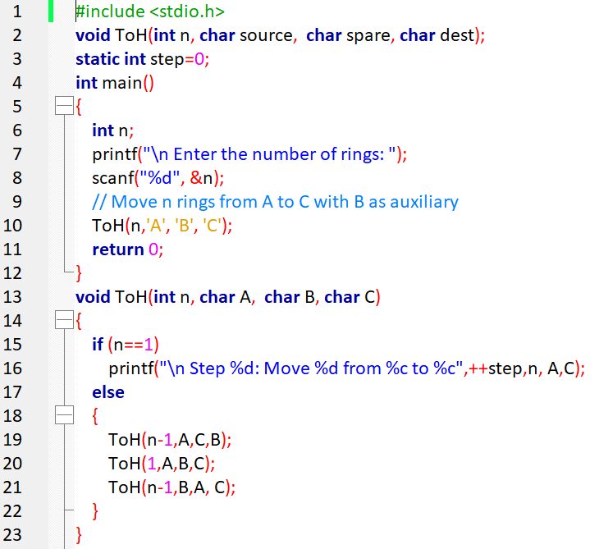

OUTPUT
Enter the number of rings: 4
Step 1: Move 1 from A to B
Step 2: Move 1 from A to C
Step 3: Move 1 from B to C
Step 4: Move 1 from A to B
Step 5: Move 1 from C to A
Step 6: Move 1 from C to B
Step 7: Move 1 from A to B
Step 8: Move 1 from A to C
Step 9: Move 1 from B to C
Step 10: Move 1 from B to A
Step 11: Move 1 from C to A
Step 12: Move 1 from B to C
Step 13: Move 1 from A to B
Step 14: Move 1 from A to C
Step 15: Move 1 from B to C

Program 7 Call holding in call center
A Call center phone system has to hold the phone calls from customers and provide service based on the arrival time of the calls. Write a C program to simulate this system using appropriate data structure. Program should have options to add and remove the phone calls in appropriate order for their service.

Warning! You are warned against blindly copying the code statements. Read the code and comments to understand the implementation. Then, try to do it yourself. Blindly re-typing the code statements is a waste of time & effort.

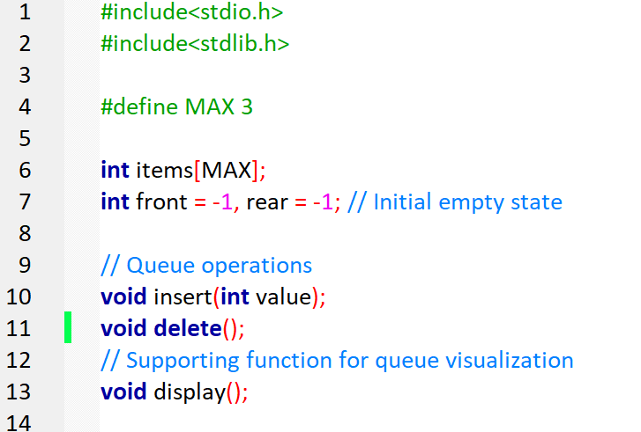
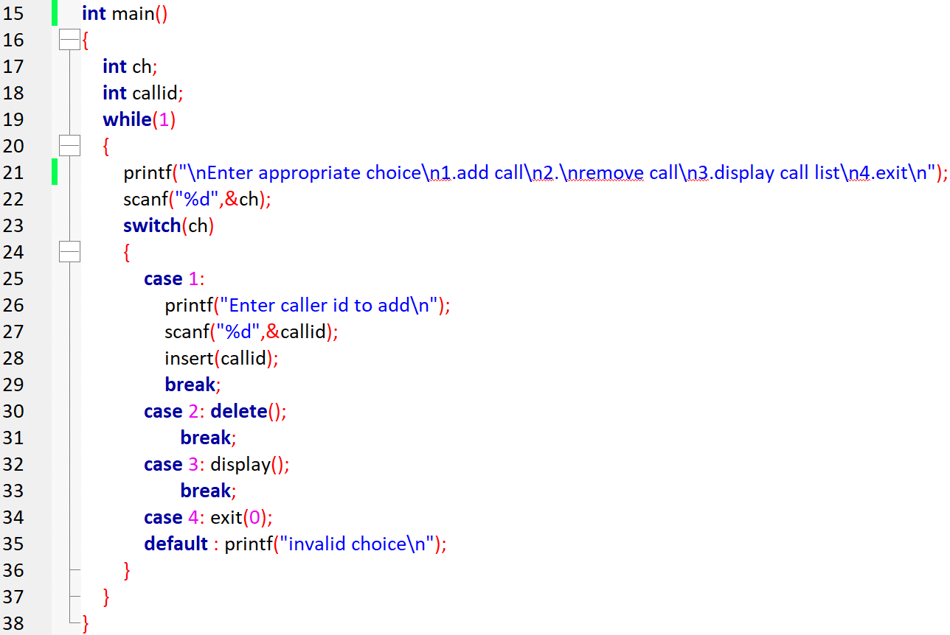

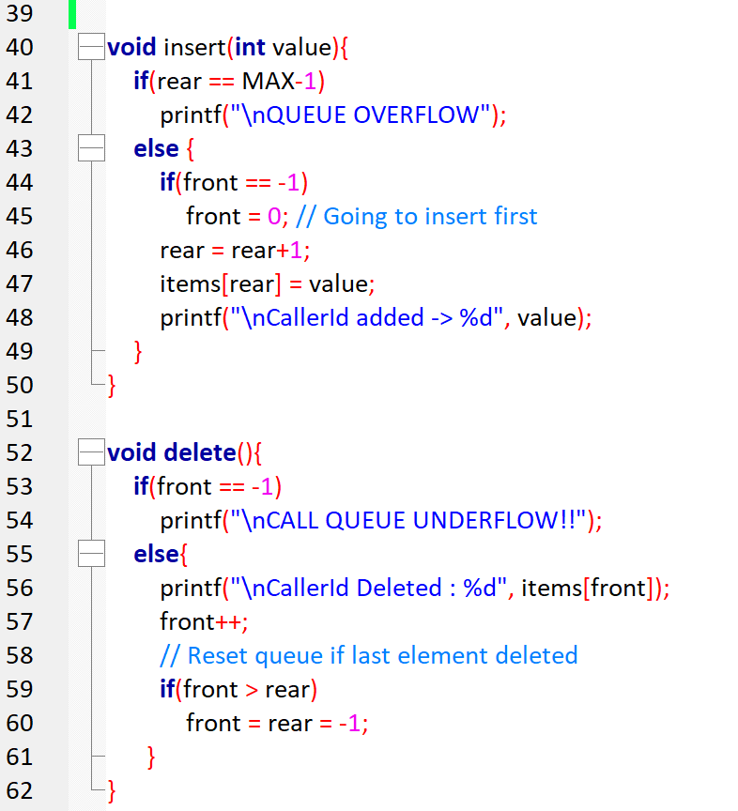

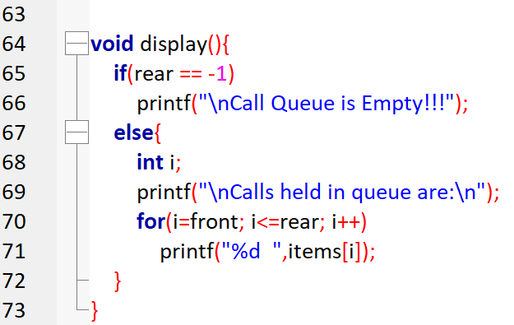

OUTPUT:
Enter appropriate choice
1.add call
2.remove call
3.display call list
4.exit
1
Enter caller id to add
2345

CallerId added -> 2345
Enter appropriate choice
1.add call
2.remove call
3.display call list
4.exit
1
Enter caller id to add
7865

CallerId added -> 7865
Enter appropriate choice
1.add call
2.remove call
3.display call list
4.exit
1
Enter caller id to add
7777

CallerId added -> 7777
Enter appropriate choice
1.add call
2.remove call
3.display call list
4.exit
3

Calls held in queue are:
2345 7865 7777
Enter appropriate choice
1.add call
2.remove call
3.display call list
4.exit
1
Enter caller id to add
9999

QUEUE OVERFLOW
Enter appropriate choice
1.add call
2.remove call
3.display call list
4.exit
2

CallerId Deleted : 2345
Enter appropriate choice
1.add call
2.remove call
3.display call list
4.exit
3

Calls held in queue are:
7865 7777
Enter appropriate choice
1.add call
2.remove call
3.display call list
4.exit
2

CallerId Deleted : 7865
Enter appropriate choice
1.add call
2.remove call
3.display call list
4.exit
3

Calls held in queue are:
7777
Enter appropriate choice
1.add call
2.remove call
3.display call list
4.exit
2

CallerId Deleted : 7777
Enter appropriate choice
1.add call
2.remove call
3.display call list
4.exit
3

Call Queue is Empty!!!
Enter appropriate choice
1.add call
2.remove call
3.display call list
4.exit
2

CALL QUEUE UNDERFLOW!!
Enter appropriate choice
1.add call
2.remove call
3.display call list
4.exit

Program 8 Circular Queue using Structure
Write a C program to simulate the working of a Circular Queue of integers. Represent a circular queue element as a structure and use an array of structures as your implementation method. Start and end of the circular queue must be identified by an empty array element.

Warning! You are warned against blindly copying the code statements. Read the code and comments to understand the implementation. Then, try to do it yourself. Blindly re-typing the code statements is a waste of time & effort.

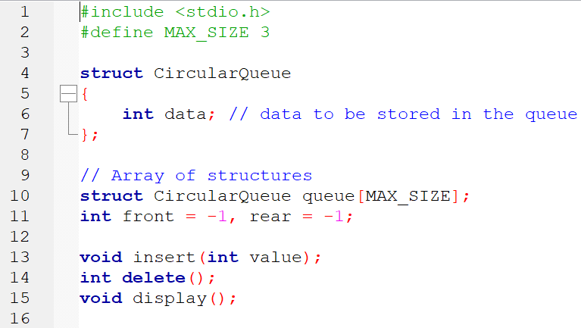
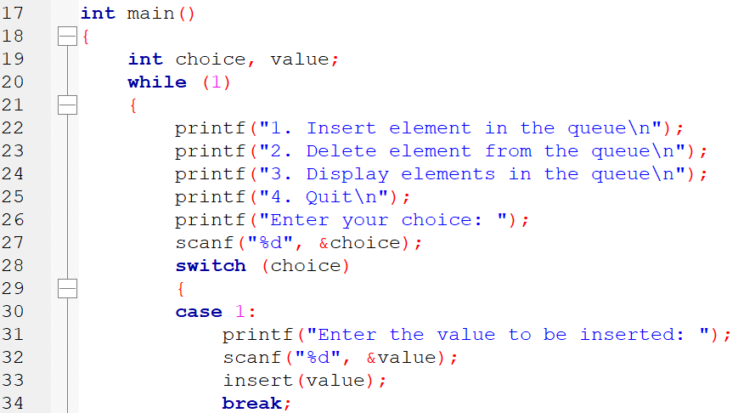
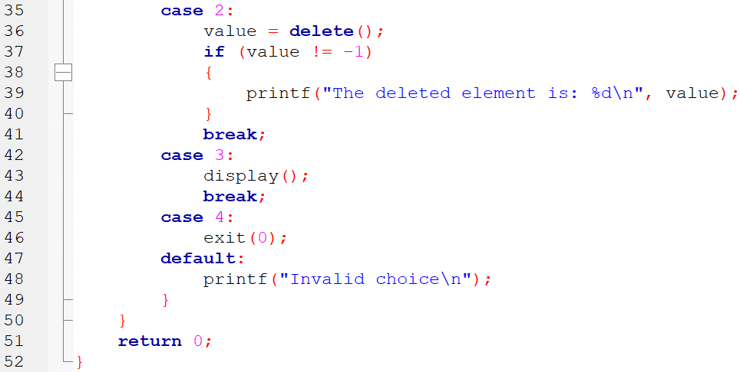
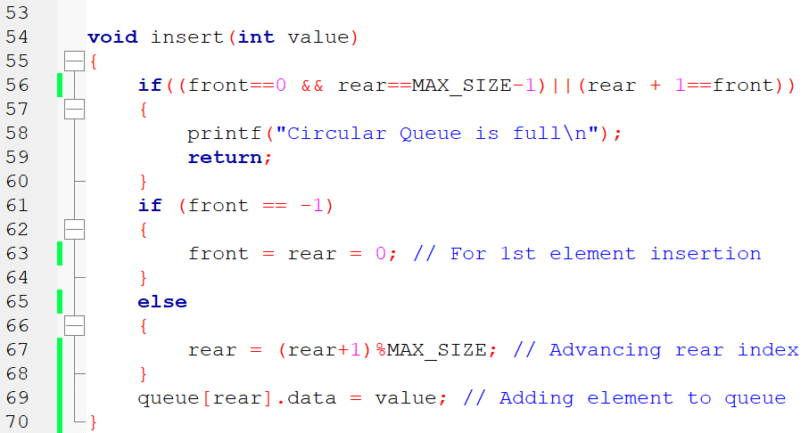
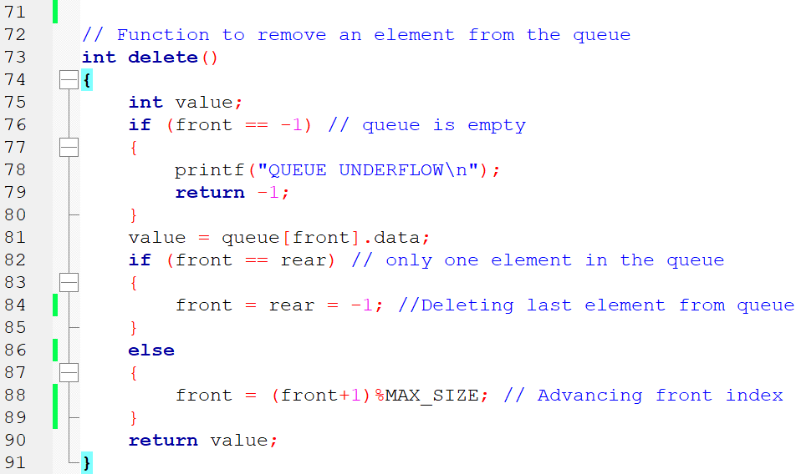
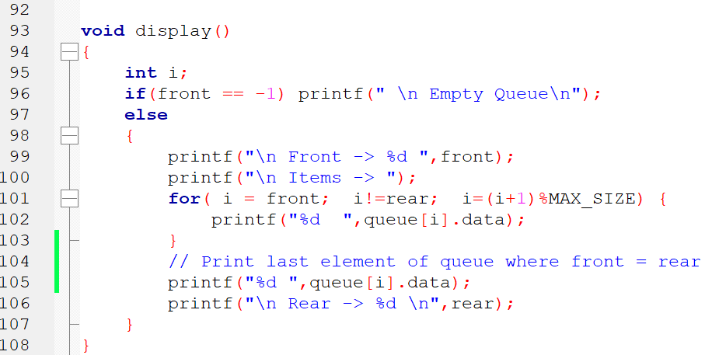

OUTPUT
1. Insert element in the queue
2. Delete element from the queue
3. Display elements in the queue
4. Quit
Enter your choice: 1
Enter the value to be inserted: 45
1. Insert element in the queue
2. Delete element from the queue
3. Display elements in the queue
4. Quit
Enter your choice: 1
Enter the value to be inserted: 67
1. Insert element in the queue
2. Delete element from the queue
3. Display elements in the queue
4. Quit
Enter your choice: 3

Front -> 0
Items -> 45 67
Rear -> 1
1. Insert element in the queue
2. Delete element from the queue
3. Display elements in the queue
4. Quit
Enter your choice: 1
Enter the value to be inserted: 78
1. Insert element in the queue
2. Delete element from the queue
3. Display elements in the queue
4. Quit
Enter your choice: 1
Enter the value to be inserted: 99
Circular Queue is full
1. Insert element in the queue
2. Delete element from the queue
3. Display elements in the queue
4. Quit
Enter your choice: 3

Front -> 0
Items -> 45 67 78
Rear -> 2
1. Insert element in the queue
2. Delete element from the queue
3. Display elements in the queue
4. Quit
Enter your choice: 2
The deleted element is: 45
1. Insert element in the queue
2. Delete element from the queue
3. Display elements in the queue
4. Quit
Enter your choice: 3

Front -> 1
Items -> 67 78
Rear -> 2
1. Insert element in the queue
2. Delete element from the queue
3. Display elements in the queue
4. Quit
Enter your choice: 1
Enter the value to be inserted: 99
1. Insert element in the queue
2. Delete element from the queue
3. Display elements in the queue
4. Quit
Enter your choice: 3

Front -> 1
Items -> 67 78 99
Rear -> 0
1. Insert element in the queue
2. Delete element from the queue
3. Display elements in the queue
4. Quit

Improved solution for CQ of student data

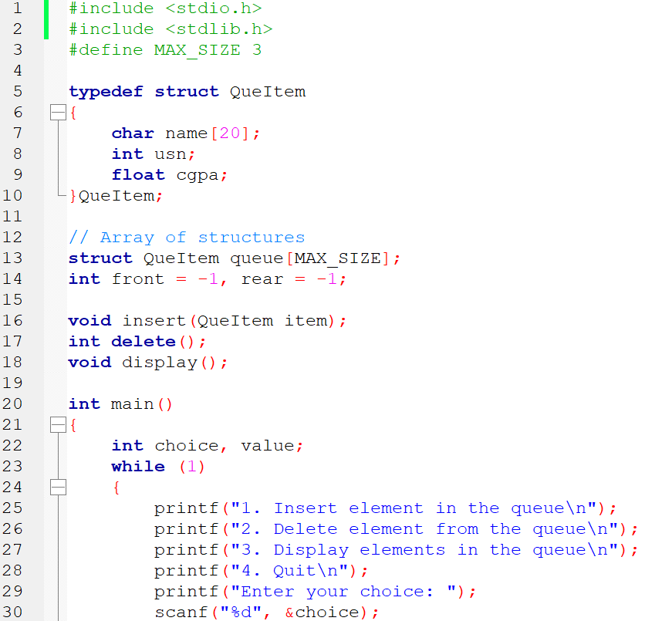
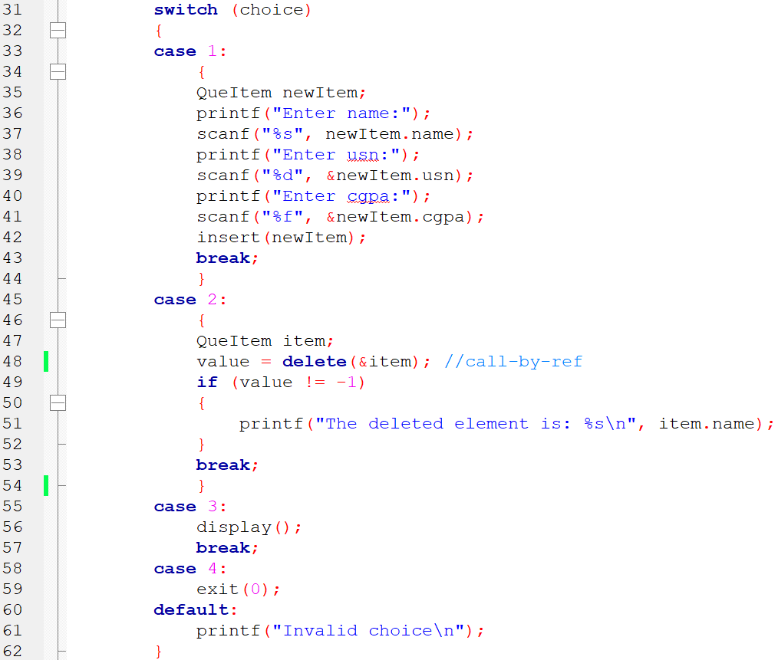
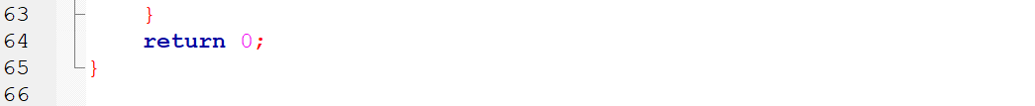
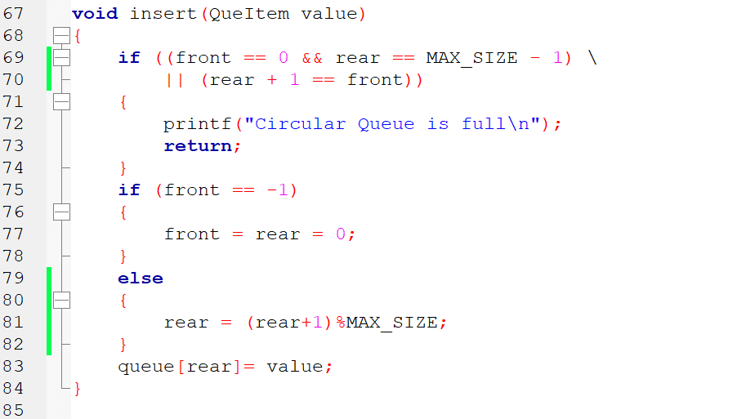
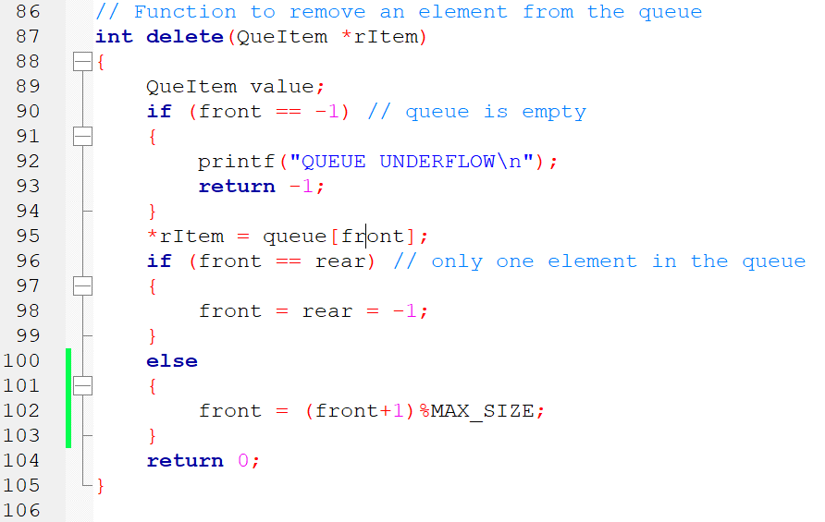
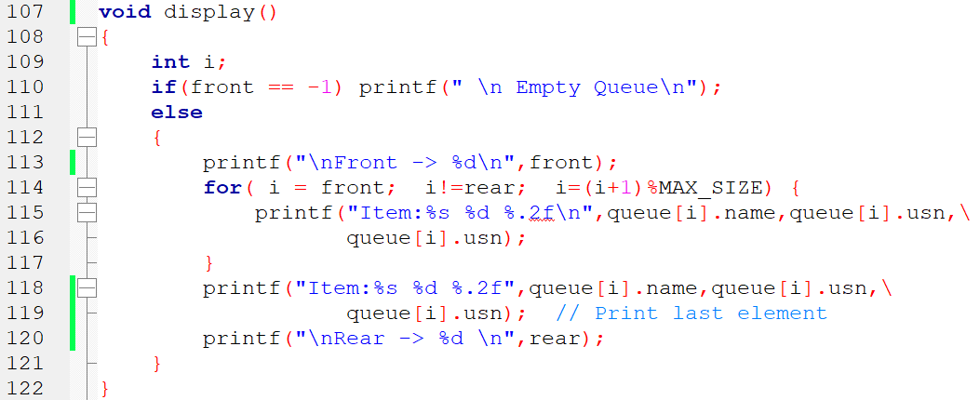

OUTPUT:
1. Insert element in the queue
2. Delete element from the queue
3. Display elements in the queue
4. Quit
Enter your choice: 1
Enter name:amit
Enter usn:123
Enter cgpa:8.99
1. Insert element in the queue
2. Delete element from the queue
3. Display elements in the queue
4. Quit
Enter your choice: 3

Front -> 0
Item:amit 123 0.00
Rear -> 0

1. Insert element in the queue
2. Delete element from the queue
3. Display elements in the queue
4. Quit
Enter your choice: 1
Enter name:rahul
Enter usn:3456
Enter cgpa:9.56
1. Insert element in the queue
2. Delete element from the queue
3. Display elements in the queue
4. Quit
Enter your choice: 3

Front -> 0
Item:amit 123 0.00
Item:rahul 3456 0.00
Rear -> 1

1. Insert element in the queue
2. Delete element from the queue
3. Display elements in the queue
4. Quit

Program 9 Linked list for sorted names
Write a program to create a singly linked list that maintains a list of names in alphabetical order. Implement the following operations on the list.
a. Insert a new name
b. Delete a specified name
Warning! You are warned against blindly copying the code statements. Read the code and comments to understand the implementation. Then, try to do it yourself. Blindly re-typing the code statements is a waste of time & effort.

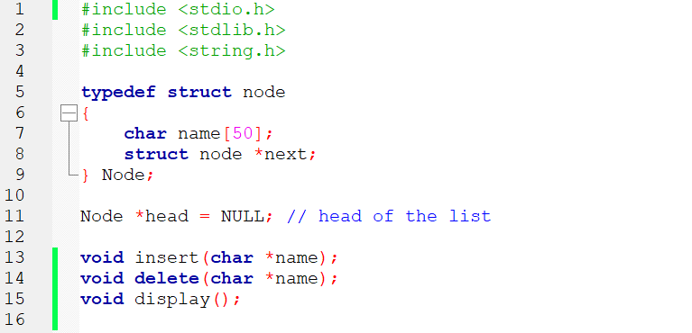
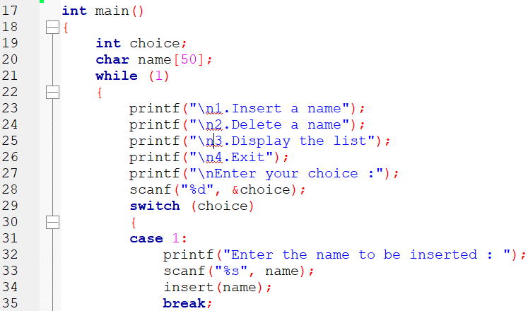
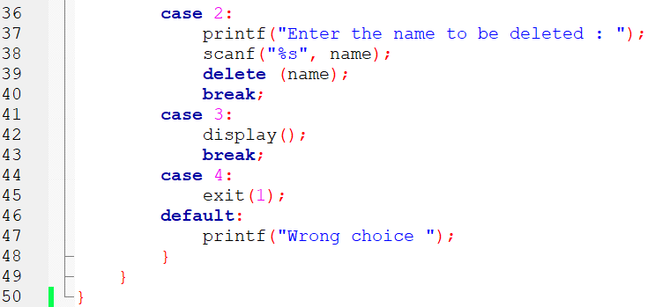
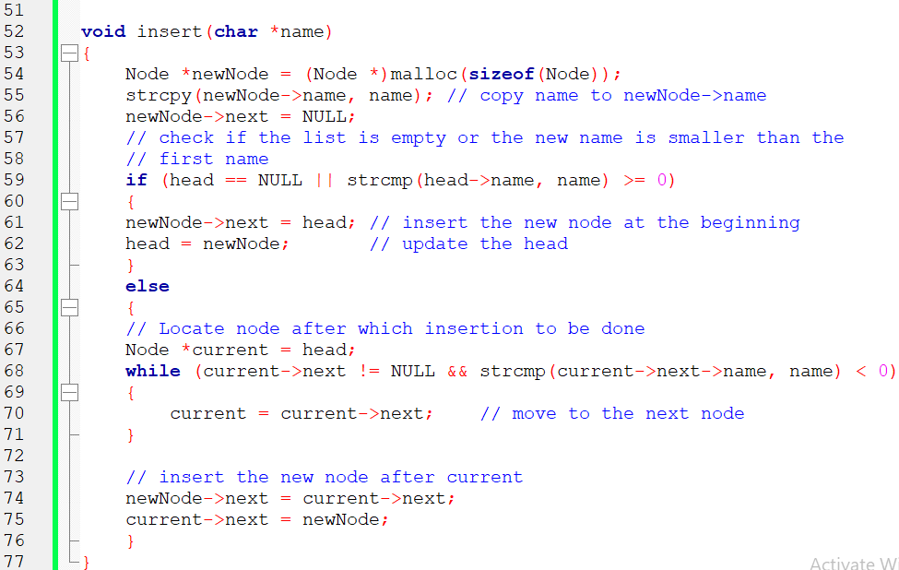
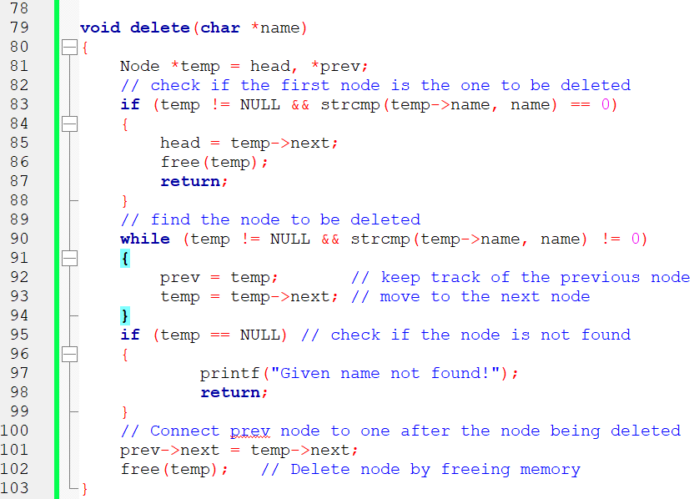
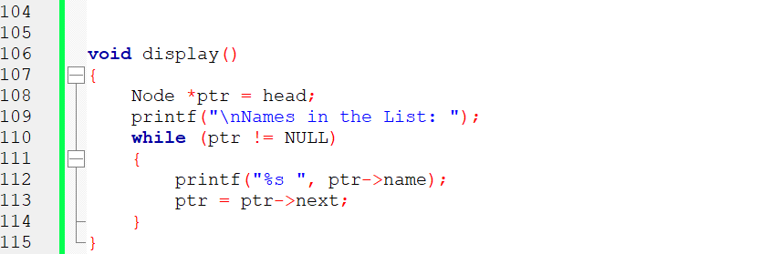

OUTPUT:
1.Insert a name
2.Delete a name
3.Display the list
4.Exit
Enter your choice :1
Enter the name to be inserted : Rohan

1.Insert a name
2.Delete a name
3.Display the list
4.Exit
Enter your choice :1
Enter the name to be inserted : Akshay

1.Insert a name
2.Delete a name
3.Display the list
4.Exit
Enter your choice :3

Names in the List: Akshay Rohan
1.Insert a name
2.Delete a name
3.Display the list
4.Exit
Enter your choice :1
Enter the name to be inserted : Kiran

1.Insert a name
2.Delete a name
3.Display the list
4.Exit
Enter your choice :3

Names in the List: Akshay Kiran Rohan
1.Insert a name
2.Delete a name
3.Display the list
4.Exit
Enter your choice :2
Enter the name to be deleted : Kiran

1.Insert a name
2.Delete a name
3.Display the list
4.Exit
Enter your choice :3

Names in the List: Akshay Rohan
1.Insert a name
2.Delete a name
3.Display the list
4.Exit
Enter your choice :2
Enter the name to be deleted : Shekar
Given name not found!
1.Insert a name
2.Delete a name
3.Display the list
4.Exit

Program 10 Stack using Linked List
Write a C program to maintain a stack of integers using a linked list implementation method.

Warning! You are warned against blindly copying the code statements. Read the code and comments to understand the implementation. Then, try to do it yourself. Blindly re-typing the code statements is a waste of time & effort.

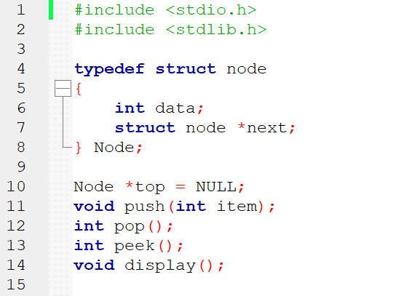
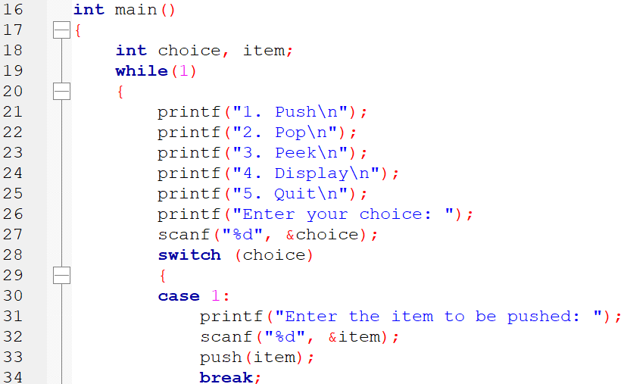
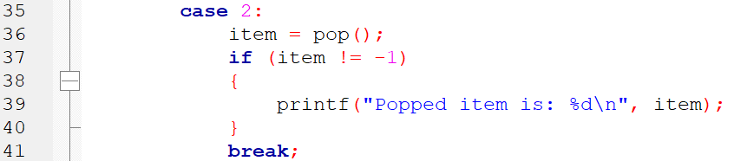
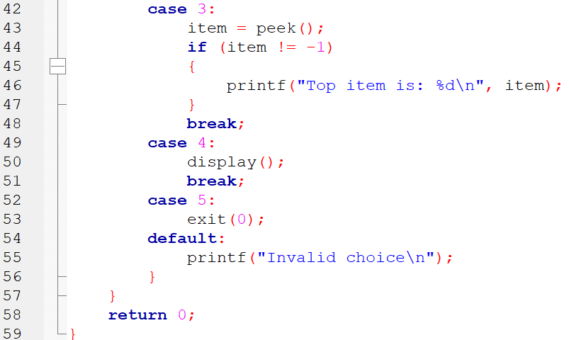
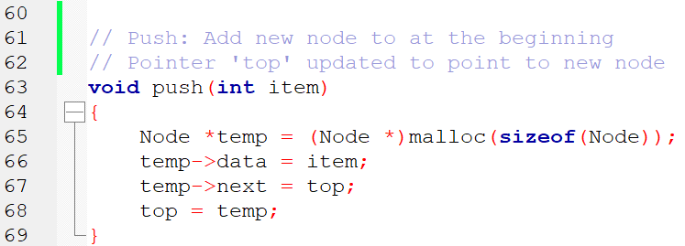
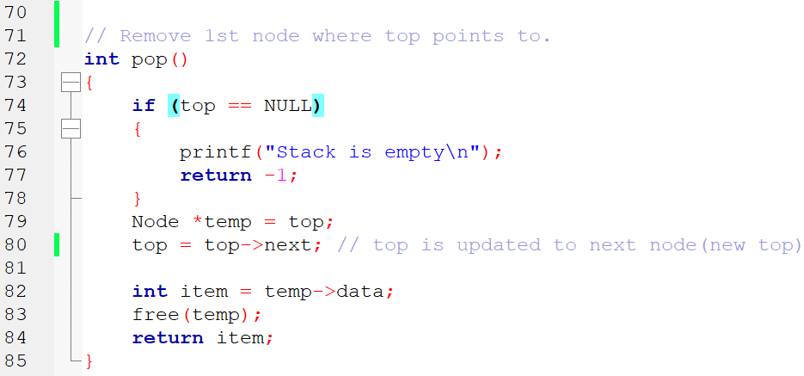
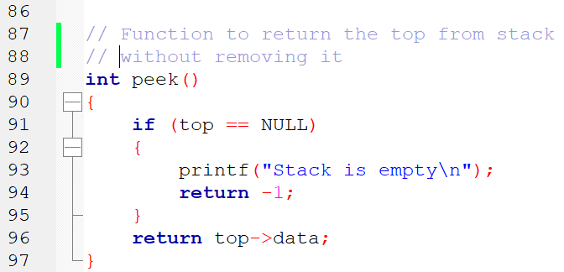
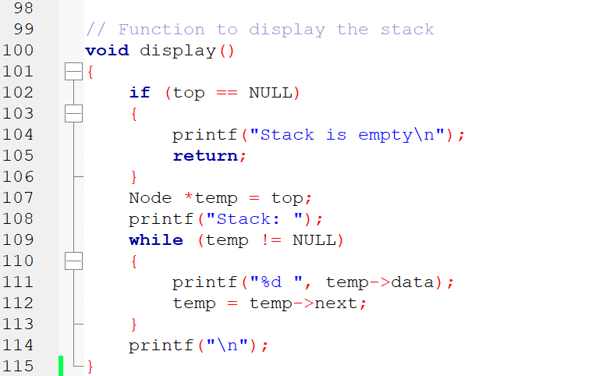

OUTPUT:
1. Push
2. Pop
3. Peek
4. Display
5. Quit
Enter your choice: 1
Enter the item to be pushed: 45
1. Push
2. Pop
3. Peek
4. Display
5. Quit
Enter your choice: 1
Enter the item to be pushed: 56
1. Push
2. Pop
3. Peek
4. Display
5. Quit
Enter your choice: 3
Top item is: 56
1. Push
2. Pop
3. Peek
4. Display
5. Quit
Enter your choice: 2
Popped item is: 56
1. Push
2. Pop
3. Peek
4. Display
5. Quit
Enter your choice: 1
Enter the item to be pushed: 99
1. Push
2. Pop
3. Peek
4. Display
5. Quit
Enter your choice: 4
Stack: 99 45
1. Push
2. Pop
3. Peek
4. Display
5. Quit
Enter your choice: 2
Popped item is: 99
1. Push
2. Pop
3. Peek
4. Display
5. Quit
Enter your choice: 2
Popped item is: 45
1. Push
2. Pop
3. Peek
4. Display
5. Quit
Enter your choice: 2
Stack is empty

Program 11 Doubly Linked List implementation
Write a C program to support the following operations on a doubly linked list.
a) Insert a new node to the left of the node whose key value is read as an input.
b) Delete a node with given data, if it is found otherwise display appropriate error message.

Warning! You are warned against blindly copying the code statements. Read the code and comments to understand the implementation. Then, try to do it yourself. Blindly re-typing the code statements is a waste of time & effort.

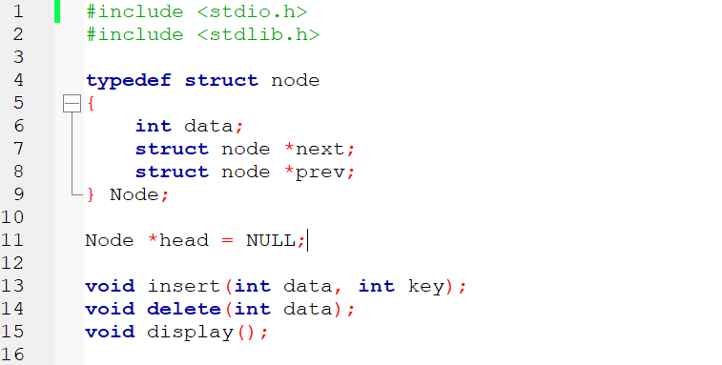
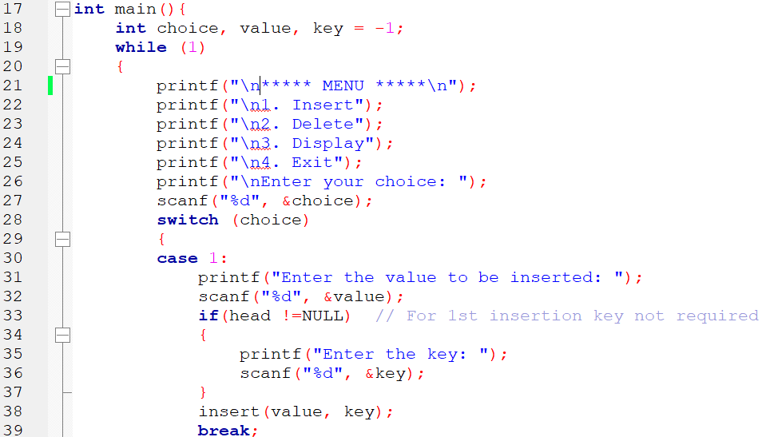

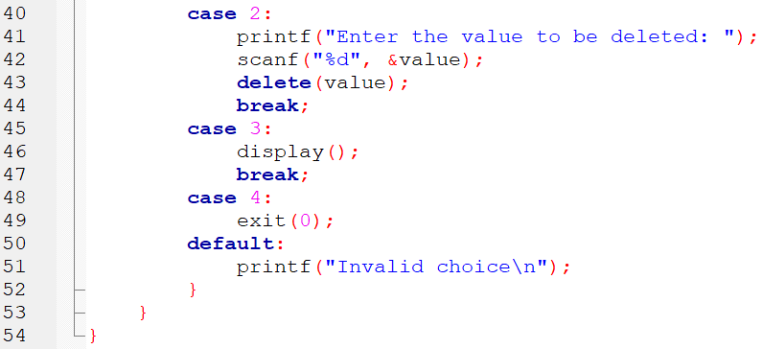
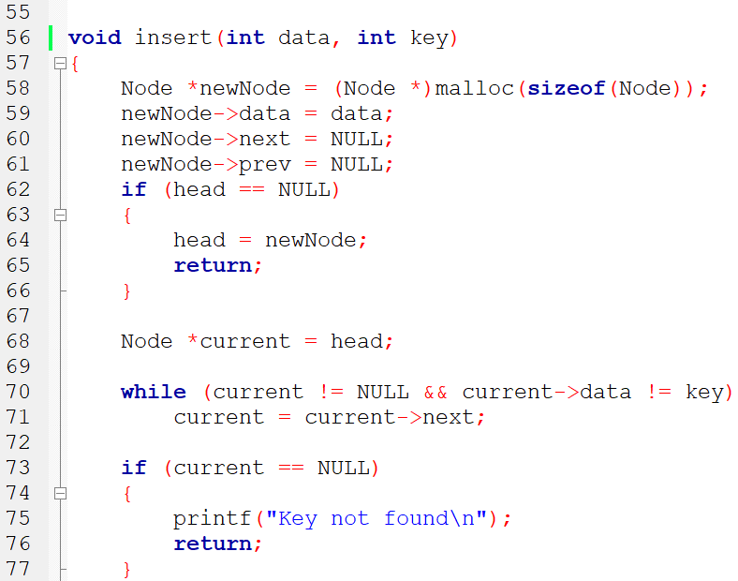
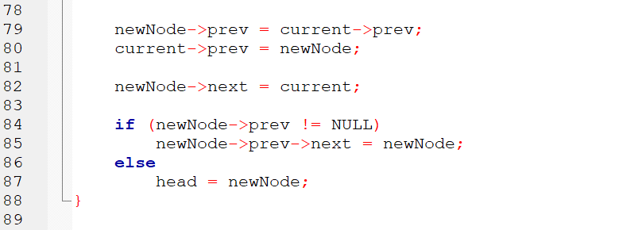
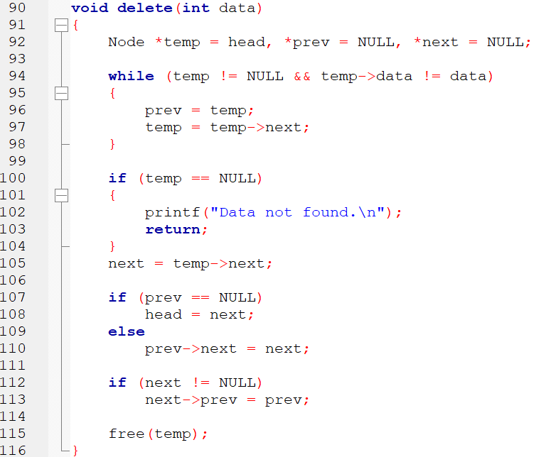

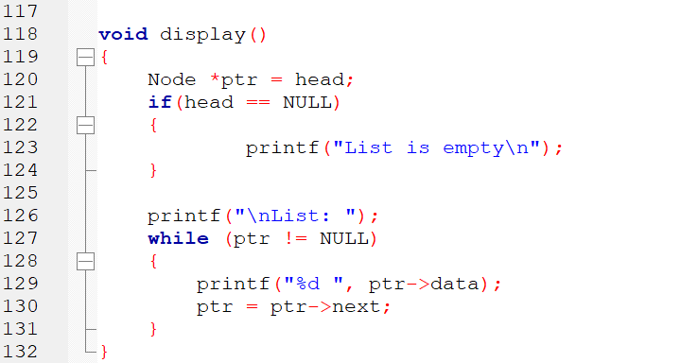

OUTPUT
***** MENU *****
1. Insert
2. Delete
3. Display
4. Exit
Enter your choice: 1
Enter the value to be inserted: 50

***** MENU *****
1. Insert
2. Delete
3. Display
4. Exit
Enter your choice: 1
Enter the value to be inserted: 70
Enter the key: 50

***** MENU *****
1. Insert
2. Delete
3. Display
4. Exit
Enter your choice: 3

List: 70 50

***** MENU *****
1. Insert
2. Delete
3. Display
4. Exit
Enter your choice: 1
Enter the value to be inserted: 60
Enter the key: 50

***** MENU *****
1. Insert
2. Delete
3. Display
4. Exit
Enter your choice: 3

List: 70 60 50

***** MENU *****
1. Insert
2. Delete
3. Display
4. Exit
Enter your choice: 2
Enter the value to be deleted: 60

***** MENU *****
1. Insert
2. Delete
3. Display
4. Exit
Enter your choice: 3

List: 70 50

***** MENU *****
1. Insert
2. Delete
3. Display
4. Exit
Enter your choice: 2
Enter the value to be deleted: 100
Data not found.

Program 12 Binary Search Tree implementation
Write a C program
a) To construct a binary search tree of integers.
b) To traverse the tree using inorder, preorder and postorder traversal methods

Warning! You are warned against blindly copying the code statements. Read the code and comments to understand the implementation. Then, try to do it yourself. Blindly re-typing the code statements is a waste of time & effort.

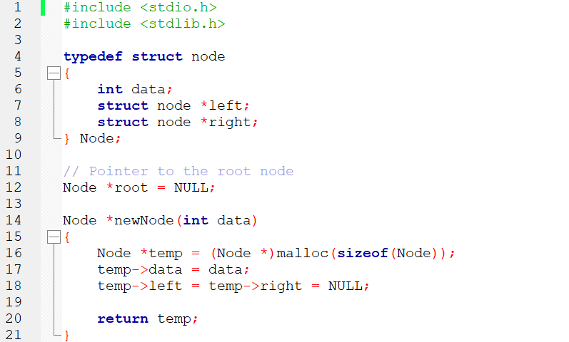
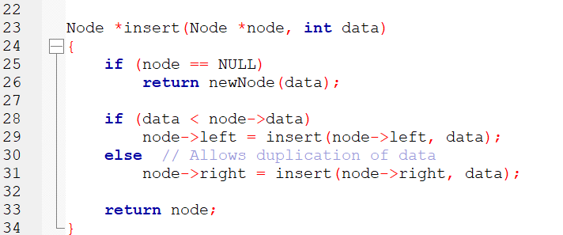
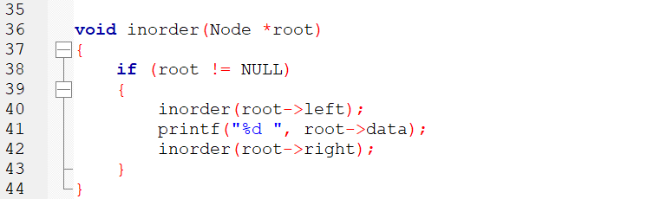
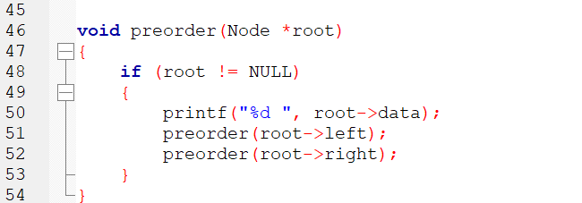
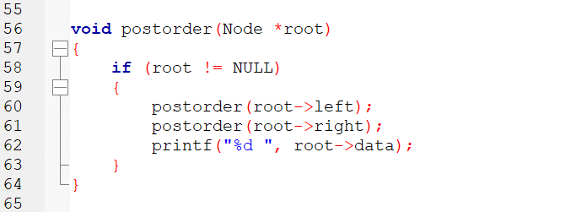
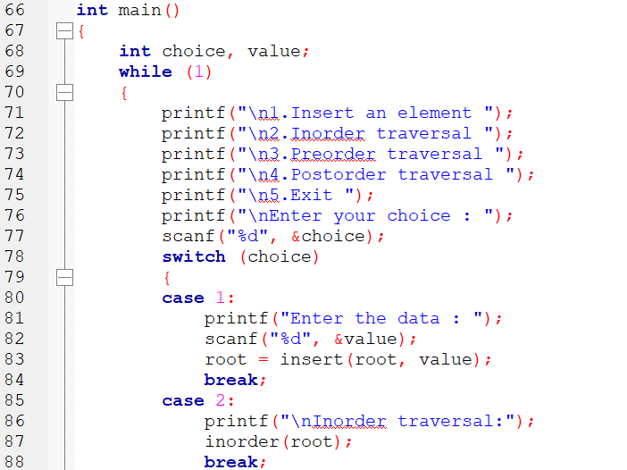
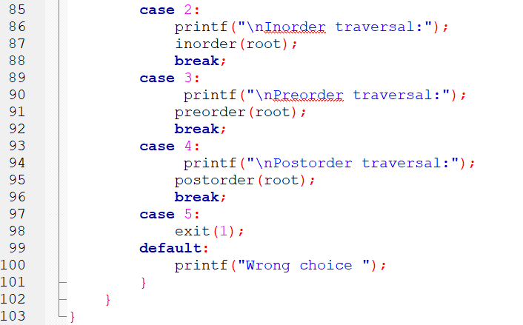

OUTPUT

1.Insert an element
2.Inorder traversal
3.Preorder traversal
4.Postorder traversal
5.Exit
Enter your choice : 1
Enter the data : 40

1.Insert an element
2.Inorder traversal
3.Preorder traversal
4.Postorder traversal
5.Exit
Enter your choice : 1
Enter the data : 20

1.Insert an element
2.Inorder traversal
3.Preorder traversal
4.Postorder traversal
5.Exit
Enter your choice : 1
Enter the data : 60

1.Insert an element
2.Inorder traversal
3.Preorder traversal
4.Postorder traversal
5.Exit
Enter your choice : 1
Enter the data : 10

1.Insert an element
2.Inorder traversal
3.Preorder traversal
4.Postorder traversal
5.Exit
Enter your choice : 1
Enter the data : 30

1.Insert an element
2.Inorder traversal
3.Preorder traversal
4.Postorder traversal
5.Exit
Enter your choice : 2

Inorder traversal:10 20 30 40 60
1.Insert an element
2.Inorder traversal
3.Preorder traversal
4.Postorder traversal
5.Exit
Enter your choice : 3

Preorder traversal:40 20 10 30 60
1.Insert an element
2.Inorder traversal
3.Preorder traversal
4.Postorder traversal
5.Exit
Enter your choice : 4

Postorder traversal:10 30 20 60 40

